Министерство науки и высшего образования Российской Федерации
Муромский институт (филиал)
федерального государственного бюджетного образовательного учреждения высшего образования
«Владимирский государственный университет
Имени Александра Григорьевича и Николая Григорьевича Столетовых»
(МИВлГУ)

Факультет ИТР
Кафедра ПИн

ЛАБОРАТОРНАЯ
РАБОТА №2

по Разработка корпоративных приложений
Тема Связи между таблицами

Руководитель
Кульков Я.Ю.
(фамилия, инициалы)

(подпись) (дата)

Студент ПИн-122
(группа)
Загребин Д. А.
(фамилия, инициалы)

(подпись) (дата)

Муром 2025
Лабораторная работа №2
Тема: Связи между таблицами
Цель: Создание Spring-приложения с несколькими таблицами с использованием Java Persistent API
Задание:
1. Рассмотреть пример из лабораторной работы
2. Создать набор сущностей в зависимости от варианта (либо по теме курсовой работы). Не менее трех связанных таблиц.
3. Реализовать web-приложение для работы с соответствующими данными.
4. Базовые действия: вывод информации о всех экземплярах и ввод нового.
5. Реализовать поиск и отбор данных по различным критериям, не менее трех комбинаций.
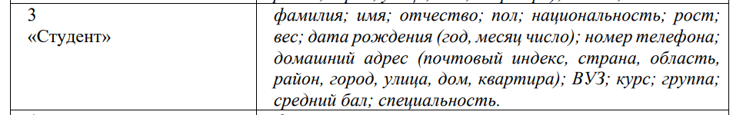

Ход работы:
Листинг 1 MainController.java:
package ru.zagrebin.laba11;

import org.springframework.beans.factory.annotation.Autowired;
import org.springframework.stereotype.Controller;
import org.springframework.ui.Model;
import org.springframework.web.bind.annotation.*;
import ru.zagrebin.laba11.entity.Address;
import ru.zagrebin.laba11.entity.Student;
import ru.zagrebin.laba11.entity.StudentGroup;
import ru.zagrebin.laba11.form.StudentForm;
import ru.zagrebin.laba11.service.*;

import java.util.Optional;

@Controller
public class MainController {
private final ServiceStudent serviceStudent;
private final ServiceAddress serviceAddress;
private final ServiceStudentGroup serviceStudentGroup;
private final ServiceUniversity serviceUniversity;
private final ServiceCourse serviceCourse;

@Autowired
public MainController(ServiceStudent serviceStudent, ServiceAddress serviceAddress, ServiceStudentGroup serviceStudentGroup, ServiceUniversity serviceUniversity, ServiceCourse serviceCourse) {
this.serviceStudent = serviceStudent;
this.serviceAddress = serviceAddress;
this.serviceStudentGroup = serviceStudentGroup;
this.serviceUniversity = serviceUniversity;
this.serviceCourse = serviceCourse;
}

@GetMapping("/institut")
public String institut(Model model) {
model.addAttribute("students", serviceStudent.getAllStudents());
return "main";
}

@GetMapping("/details/{id}")
public String details(@PathVariable("id") Long id, Model model) {
Optional<Student> selectedStudent = serviceStudent.getStudentById(id);
if (selectedStudent.isPresent()) {
model.addAttribute("student", selectedStudent.get());
return "details";
}
return "redirect:/institut";
}

@GetMapping("/students/delete/{id}")
public String delete(@PathVariable("id") Long id) {
serviceStudent.deleteStudentById(id);
return "redirect:/institut";
}

@GetMapping("/students/addStudentForm")
public String addStudentForm(Model model) {
model.addAttribute("studentForm", new StudentForm());
model.addAttribute("addresses", serviceAddress.findAllAddress());
model.addAttribute("groups", serviceStudentGroup.findAllStudentGroup());
return "addStudentForm";
}

@PostMapping("/students/addStudentForm")
public String addStudent(@ModelAttribute StudentForm studentForm) {
Student student = new Student();
convertFormToEntity(studentForm, student);
serviceStudent.saveStudent(student);
return "redirect:/institut";
}

@GetMapping("/students/editStudent/{id}")
public String editStudentForm(@PathVariable("id") Long id, Model model) {
Optional<Student> student = serviceStudent.getStudentById(id);
if (student.isPresent()) {
StudentForm studentForm = new StudentForm();
convertEntityToForm(student.get(), studentForm);

model.addAttribute("studentForm", studentForm);
model.addAttribute("addresses", serviceAddress.findAllAddress());
model.addAttribute("groups", serviceStudentGroup.findAllStudentGroup());
return "addStudentForm";
}
return "redirect:/institut";
}

@GetMapping("/students/search")
public String searchForm(Model model) {
model.addAttribute("searchType", "lastName");
return "search";
}

@PostMapping("/students/search")
public String searchResults(@RequestParam String searchType,
@RequestParam String searchValue,
Model model) {
switch (searchType) {
case "lastName":
model.addAttribute("students", serviceStudent.findByLastName(searchValue));
break;
case "city":
model.addAttribute("students", serviceStudent.findByCity(searchValue));
break;
case "gpa":
try {
Double gpa = Double.parseDouble(searchValue);
model.addAttribute("students", serviceStudent.findByGpaGreaterThanEqual(gpa));
} catch (NumberFormatException e) {
model.addAttribute("error", "Введите корректное число для GPA");
}
break;
case "group":
model.addAttribute("students", serviceStudent.findByGroupName(searchValue));
break;
case "speciality":
model.addAttribute("students", serviceStudent.findBySpeciality(searchValue));
break;
}

model.addAttribute("searchType", searchType);
model.addAttribute("searchValue", searchValue);
return "search";
}

private void convertFormToEntity(StudentForm form, Student student) {
student.setId(form.getId());
student.setLastName(form.getLastName());
student.setFirstName(form.getFirstName());
student.setPatronymic(form.getPatronymic());
student.setGender(form.getGender());
student.setNationality(form.getNationality());
student.setHeight(form.getHeight());
student.setWeight(form.getWeight());
student.setBirthDate(form.getBirthDate());
student.setPhoneNumber(form.getPhoneNumber());
student.setGpa(form.getGpa());

if (form.getAddressId() != null) {
Address address = serviceAddress.findAddressById(form.getAddressId());
student.setAddress(address);
}

if (form.getStudentGroupId() != null) {
StudentGroup group = serviceStudentGroup.findStudentGroupById(form.getStudentGroupId());
student.setStudentGroup(group);
}
}

private void convertEntityToForm(Student student, StudentForm form) {
form.setId(student.getId());
form.setLastName(student.getLastName());
form.setFirstName(student.getFirstName());
form.setPatronymic(student.getPatronymic());
form.setGender(student.getGender());
form.setNationality(student.getNationality());
form.setHeight(student.getHeight());
form.setWeight(student.getWeight());
form.setBirthDate(student.getBirthDate());
form.setPhoneNumber(student.getPhoneNumber());
form.setGpa(student.getGpa());

if (student.getAddress() != null) {
form.setAddressId(student.getAddress().getId());
}

if (student.getStudentGroup() != null) {
form.setStudentGroupId(student.getStudentGroup().getId());
}
}

}
Листинг 2 AddressRepository.java:
package ru.zagrebin.laba11.repository;

import org.springframework.data.repository.CrudRepository;
import org.springframework.stereotype.Repository;
import ru.zagrebin.laba11.entity.Address;

import java.util.List;

@Repository
public interface AddressRepository extends CrudRepository<Address, Long> {
List<Address> findByCityContainingIgnoreCase(String city);
List<Address> findByStreetContainingIgnoreCase(String street);
}
Листинг 3 CourseRepository.java:
package ru.zagrebin.laba11.repository;

import org.springframework.data.jpa.repository.Query;
import org.springframework.data.repository.CrudRepository;
import org.springframework.data.repository.query.Param;
import org.springframework.stereotype.Repository;
import ru.zagrebin.laba11.entity.Course;

import java.util.List;

@Repository
public interface CourseRepository extends CrudRepository<Course, Long> {
List<Course> findByNameContainingIgnoreCase(String name);
List<Course> findBySemesterContainingIgnoreCase(String semester);

@Query("select c from Course c where c.hours >= :minHours")
List<Course> findByHoursGreaterThanEqual(@Param("minHours") String minHours);
}

Листинг 4 StudentGroupRepository.java:
package ru.zagrebin.laba11.repository;

import org.springframework.data.jpa.repository.Query;
import org.springframework.data.repository.CrudRepository;
import org.springframework.data.repository.query.Param;
import org.springframework.stereotype.Repository;
import ru.zagrebin.laba11.entity.StudentGroup;

import java.util.List;

@Repository
public interface StudentGroupRepository extends CrudRepository<StudentGroup, Long> {
List<StudentGroup> findByNameContainingIgnoreCase(String name);
List<StudentGroup> findBySpecialityContainingIgnoreCase(String speciality);

@Query("select g from StudentGroup g where g.university.name like %:universityName%")
List<StudentGroup> findByUniversityName(@Param("universityName") String universityName);
}

Листинг 5 StudentReposityry.java:
package ru.zagrebin.laba11.repository;

import org.springframework.data.jpa.repository.Query;
import org.springframework.data.repository.CrudRepository;
import org.springframework.data.repository.query.Param;
import org.springframework.stereotype.Repository;
import ru.zagrebin.laba11.entity.Student;

import java.util.List;

@Repository
public interface StudentRepository extends CrudRepository<Student, Long> {
List<Student> findByLastName(String name);
List<Student> findByLastNameContainingIgnoreCase(String lastName);
List<Student> findByGpaGreaterThanEqual(Double gpa);

@Query("select s from Student s join s.address a where LOWER(a.city) like LOWER(concat('%', :city, '%'))")
List<Student> findByCity(@Param("city") String city);

@Query("select s from Student s join s.studentGroup g where LOWER(g.name) like LOWER(concat('%', :groupName, '%'))")
List<Student> findByGroupName(@Param("groupName") String groupName);

@Query("select s from Student s join s.studentGroup g where LOWER(g.speciality) like LOWER(concat('%', :speciality, '%'))")
List<Student> findBySpeciality(@Param("speciality") String speciality);

@Query("select s from Student s where LOWER(s.lastName) like LOWER(concat('%', :lastName, '%')) and s.gpa >= :gpa")
List<Student> findByLastNameAndGpa(@Param("lastName") String lastName, @Param("gpa") Double gpa);

@Query("select s from Student s join s.address a join s.studentGroup g " +
"where LOWER(a.city) like LOWER(concat('%', :city, '%')) " +
"and LOWER(g.speciality) like LOWER(concat('%', :speciality, '%'))")
List<Student> findByCityAndSpeciality(@Param("city") String city, @Param("speciality") String speciality);

@Query("select s from Student s join s.studentGroup g " +
"where LOWER(g.name) like LOWER(concat('%', :groupName, '%')) " +
"and LOWER(s.lastName) like LOWER(concat('%', :lastName, '%'))")
List<Student> findByLastNameAndGroupName(@Param("lastName") String lastName, @Param("groupName") String groupName);
}

Листинг 6 UniversityReposityry.java:
package ru.zagrebin.laba11.repository;

import org.springframework.data.repository.CrudRepository;
import org.springframework.stereotype.Repository;
import ru.zagrebin.laba11.entity.University;

import java.util.List;

@Repository
public interface UniversityRepository extends CrudRepository<University, Long> {
List<University> findByNameContainingIgnoreCase(String name);
}

Листинг 7 ServiceAddress.java:
package ru.zagrebin.laba11.service;

import org.springframework.beans.factory.annotation.Autowired;
import org.springframework.stereotype.Service;
import ru.zagrebin.laba11.entity.Address;
import ru.zagrebin.laba11.repository.AddressRepository;

import java.util.List;

@Service
public class ServiceAddress {
@Autowired
private AddressRepository addressRepository;

public List<Address> findAllAddress() {
return (List<Address>) addressRepository.findAll();
}

public Address findAddressById(Long id) {
return addressRepository.findById(id).get();
}

public void SaveAddress(Address address) {
addressRepository.save(address);
}

public void deleteAddress(Long id) {
addressRepository.deleteById(id);
}

public List<Address> findByCity(String city) {
return addressRepository.findByCityContainingIgnoreCase(city);
}

public List<Address> findByStreet(String street) {
return addressRepository.findByStreetContainingIgnoreCase(street);
}
}
Листинг 8 ServiceGroup.java:
package ru.zagrebin.laba11.service;

import org.springframework.beans.factory.annotation.Autowired;
import org.springframework.stereotype.Service;
import ru.zagrebin.laba11.entity.Course;
import ru.zagrebin.laba11.repository.CourseRepository;

import java.util.List;

@Service
public class ServiceCourse {
@Autowired
private CourseRepository courseRepository;

public List<Course> findAllCourses() {
return (List<Course>) courseRepository.findAll();
}
public Course findCourseById(Long id) {
return courseRepository.findById(id).get();
}

public void saveCourse(Course course) {
courseRepository.save(course);
}

public void deleteCourseById(Long id) {
courseRepository.deleteById(id);
}

public List<Course> findByName(String name) {
return courseRepository.findByNameContainingIgnoreCase(name);
}

public List<Course> findBySemester(String semester) {
return courseRepository.findBySemesterContainingIgnoreCase(semester);
}

public List<Course> findByHoursGreaterThanEqual(String minHours) {
return courseRepository.findByHoursGreaterThanEqual(minHours);
}
}

Листинг 9 ServiceStudent.java:
package ru.zagrebin.laba11.service;

import org.springframework.beans.factory.annotation.Autowired;
import org.springframework.stereotype.Service;
import ru.zagrebin.laba11.entity.Student;
import ru.zagrebin.laba11.repository.StudentRepository;

import java.util.List;
import java.util.Optional;

@Service
public class ServiceStudent {
@Autowired
private StudentRepository studentRepository;

public List<Student> getAllStudents() {
return (List<Student>) studentRepository.findAll();
}

public Optional<Student> getStudentById(Long id) {
return studentRepository.findById(id);
}

public void saveStudent(Student student) {
studentRepository.save(student);
}

public void deleteStudentById(Long id) {
studentRepository.deleteById(id);
}

public boolean existsById(Long id) {
return studentRepository.existsById(id);
}

// Новые методы поиска
public List<Student> findByLastName(String lastName) {
return studentRepository.findByLastNameContainingIgnoreCase(lastName);
}

public List<Student> findByGpaGreaterThanEqual(Double gpa) {
return studentRepository.findByGpaGreaterThanEqual(gpa);
}

public List<Student> findByCity(String city) {
return studentRepository.findByCity(city);
}

public List<Student> findByGroupName(String groupName) {
return studentRepository.findByGroupName(groupName);
}

public List<Student> findBySpeciality(String speciality) {
return studentRepository.findBySpeciality(speciality);
}

public List<Student> findByLastNameAndGpa(String lastName, Double gpa) {
return studentRepository.findByLastNameAndGpa(lastName, gpa);
}

public List<Student> findByCityAndSpeciality(String city, String speciality) {
return studentRepository.findByCityAndSpeciality(city, speciality);
}

public List<Student> findByFirstNameAndGroupName(String firstName, String groupName) {
return studentRepository.findByLastNameAndGroupName(firstName, groupName);
}
}

Листинг 10 ServiceStudentGroup.java:
package ru.zagrebin.laba11.service;

import org.springframework.beans.factory.annotation.Autowired;
import org.springframework.stereotype.Service;
import ru.zagrebin.laba11.entity.StudentGroup;
import ru.zagrebin.laba11.repository.StudentGroupRepository;

import java.util.List;

@Service
public class ServiceStudentGroup {
@Autowired
private StudentGroupRepository studentGroupRepository;

public List<StudentGroup> findAllStudentGroup() {
return (List<StudentGroup>) studentGroupRepository.findAll();
}

public StudentGroup findStudentGroupById(Long id) {
return studentGroupRepository.findById(id).get();
}

public void saveStudentGroup(StudentGroup studentGroup) {
studentGroupRepository.save(studentGroup);
}

public void deleteStudentGroup(Long id) {
studentGroupRepository.deleteById(id);
}

public List<StudentGroup> findByName(String name) {
return studentGroupRepository.findByNameContainingIgnoreCase(name);
}

public List<StudentGroup> findBySpeciality(String speciality) {
return studentGroupRepository.findBySpecialityContainingIgnoreCase(speciality);
}

public List<StudentGroup> findByUniversityName(String universityName) {
return studentGroupRepository.findByUniversityName(universityName);
}
}

Листинг 11 ServiceUniversity.java:
package ru.zagrebin.laba11.service;

import org.springframework.beans.factory.annotation.Autowired;
import org.springframework.stereotype.Service;
import ru.zagrebin.laba11.entity.University;
import ru.zagrebin.laba11.repository.UniversityRepository;

import java.util.List;

@Service
public class ServiceUniversity {
@Autowired
private UniversityRepository universityRepository;

public List<University> findAllUniversity() {
return (List<University>) universityRepository.findAll();
}

public University findUniversityById(Long id) {
return universityRepository.findById(id).get();
}

public void saveUniversity(University university) {
universityRepository.save(university);
}

public void deleteUniversityById(Long id) {
universityRepository.deleteById(id);
}

public List<University> findByName(String name) {
return universityRepository.findByNameContainingIgnoreCase(name);
}
}
Листинг 12 Address.java:
package ru.zagrebin.laba11.entity;

import jakarta.persistence.*;
import lombok.AllArgsConstructor;
import lombok.Data;
import lombok.NoArgsConstructor;

import java.util.List;

@Data
@AllArgsConstructor
@NoArgsConstructor
@Entity
public class Address {
@Id
@GeneratedValue(strategy = GenerationType.IDENTITY)
private Long id;

private String city;
private String street;
private String house;
private String apartment;

@OneToMany(mappedBy = "address")
private List<Student> students;

}
Листинг 13 ServiceStudentGroup.java:
package ru.zagrebin.laba11.service;

Листинг 14 Course.java:
package ru.zagrebin.laba11.entity;

import jakarta.persistence.*;
import lombok.AllArgsConstructor;
import lombok.Data;
import lombok.NoArgsConstructor;

import java.util.List;

@Entity
@Data
@AllArgsConstructor
@NoArgsConstructor
public class Course {
@Id
@GeneratedValue(strategy = GenerationType.IDENTITY)
private Long id;

private String name;
private String semester;
private String hours;

@ManyToMany(mappedBy = "courses")
private List<Student> students;
}
Листинг 15 Student.java:
package ru.zagrebin.laba11.entity;

import jakarta.persistence.*;
import lombok.AllArgsConstructor;
import lombok.Data;
import lombok.NoArgsConstructor;

import java.time.LocalDate;
import java.util.List;

@Data
@NoArgsConstructor
@AllArgsConstructor
@Entity
@Table(name="student")
public class Student {
@Id
@GeneratedValue(strategy= GenerationType.IDENTITY)
private Long id;

@Column(name = "last_name", nullable = false)
private String lastName;

@Column(name = "first_name", nullable = false)
private String firstName;

@Column(name = "patronymic")
private String patronymic;

@Column(name = "gender")
private String gender;

@Column(name = "nationality")
private String nationality;

@Column(name = "height")
private Double height;

@Column(name = "weight")
private Double weight;

@Column(name = "birth_date")
private LocalDate birthDate;

@Column(name = "phone_number")
private String phoneNumber;

@Column(name = "gpa")
private Double gpa;

@Column(name = "speciality")
private String speciality;

@ManyToOne
@JoinColumn(name = "address_id")
private Address address;

@ManyToOne
@JoinColumn(name = "group_id")
private StudentGroup studentGroup;

@ManyToMany
@JoinTable(name = "student_courses",
joinColumns = @JoinColumn(name = "student_id"),
inverseJoinColumns = @JoinColumn(name = "course_id"))
private List<Course> courses;
}
Листинг 16 StudentGroup.java:
package ru.zagrebin.laba11.entity;

import jakarta.persistence.*;
import lombok.AllArgsConstructor;
import lombok.Data;
import lombok.NoArgsConstructor;

import java.util.List;

@Data
@AllArgsConstructor
@NoArgsConstructor
@Entity
@Table(name = "studentgroup")
public class StudentGroup {
@Id
@GeneratedValue(strategy = GenerationType.IDENTITY)
private Long id;

private String name;
private String speciality;

@ManyToOne
@JoinColumn(name = "university_id")
private University university;

@OneToMany(mappedBy = "studentGroup")
private List<Student> students;
}

Листинг 16 University.java:
package ru.zagrebin.laba11.entity;

import jakarta.persistence.*;
import lombok.AllArgsConstructor;
import lombok.Data;
import lombok.NoArgsConstructor;

import java.util.List;

@Entity
@Data
@AllArgsConstructor
@NoArgsConstructor
public class University {
@Id
@GeneratedValue(strategy = GenerationType.IDENTITY)
private Long id;

private String name;

@OneToMany(mappedBy = "university")
private List<StudentGroup> studentGroups;

}

Демонстрация работы программы:

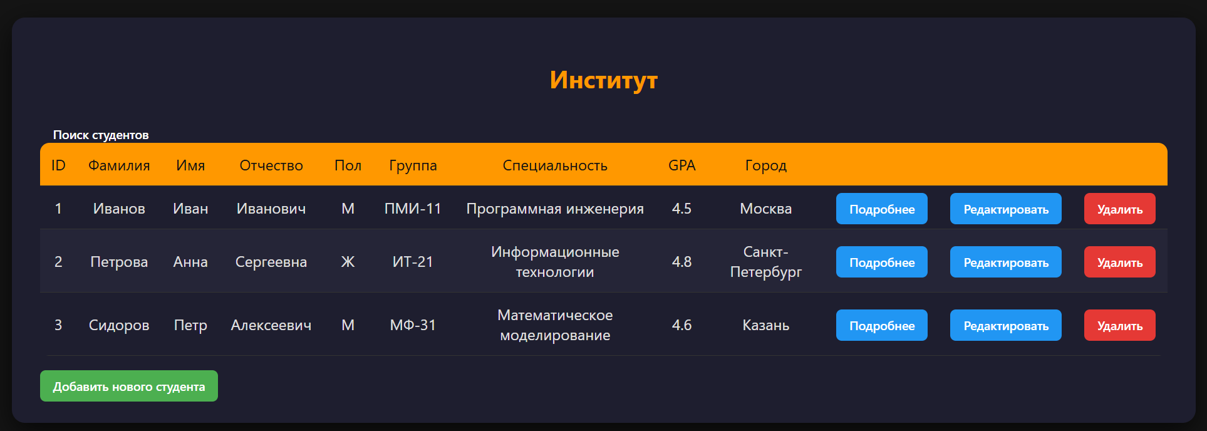
Рисунок 1 – Список студентов

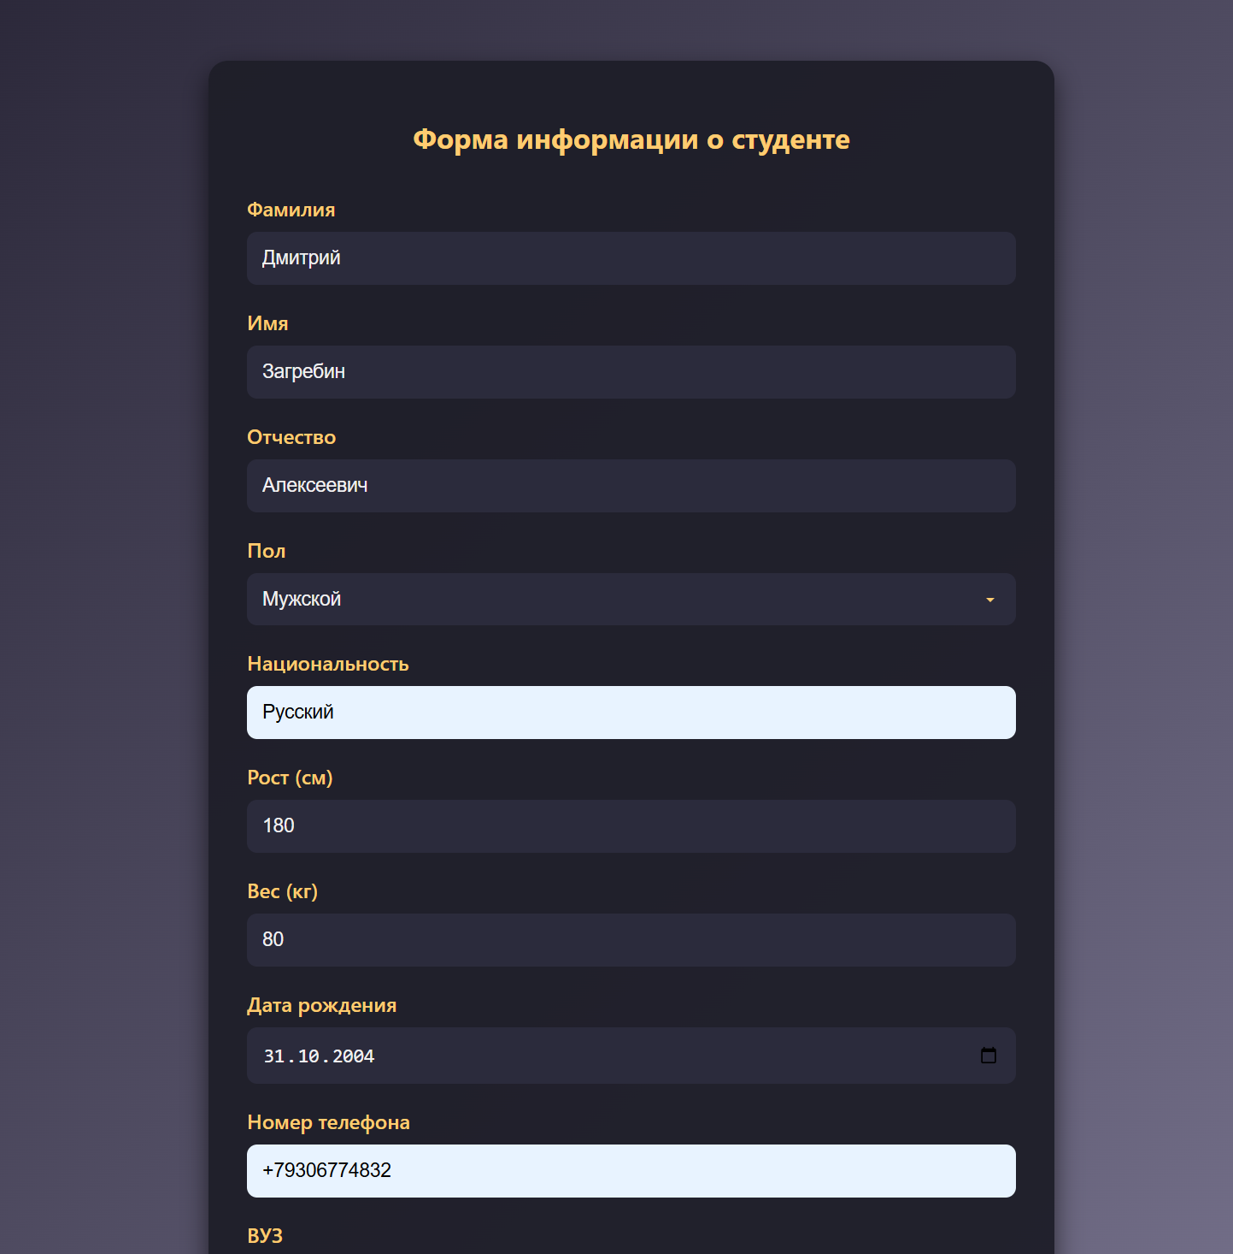
Рисунок 2 – Добавление нового студента

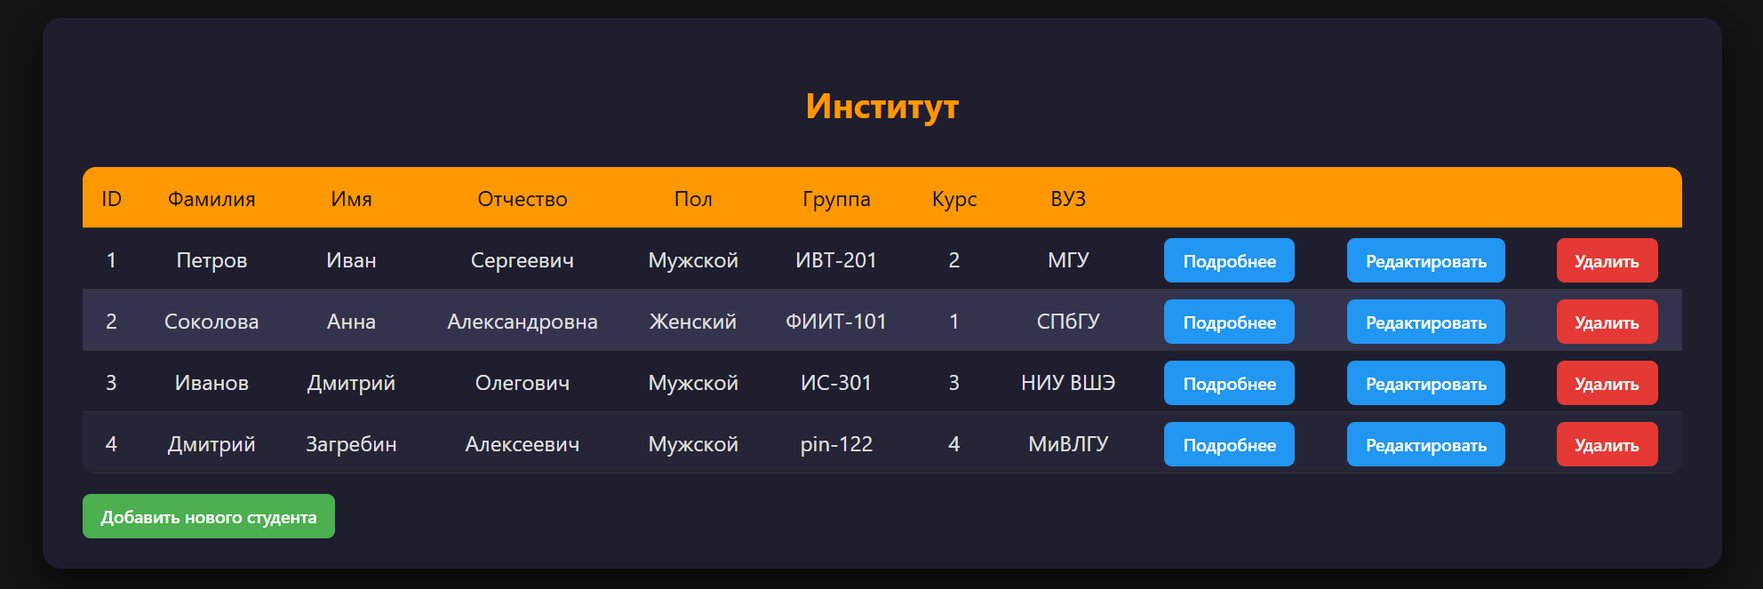Рисунок 3 – Результат добавления нового студента

У ранее созданного студента поменяем курс с 4 на 3:

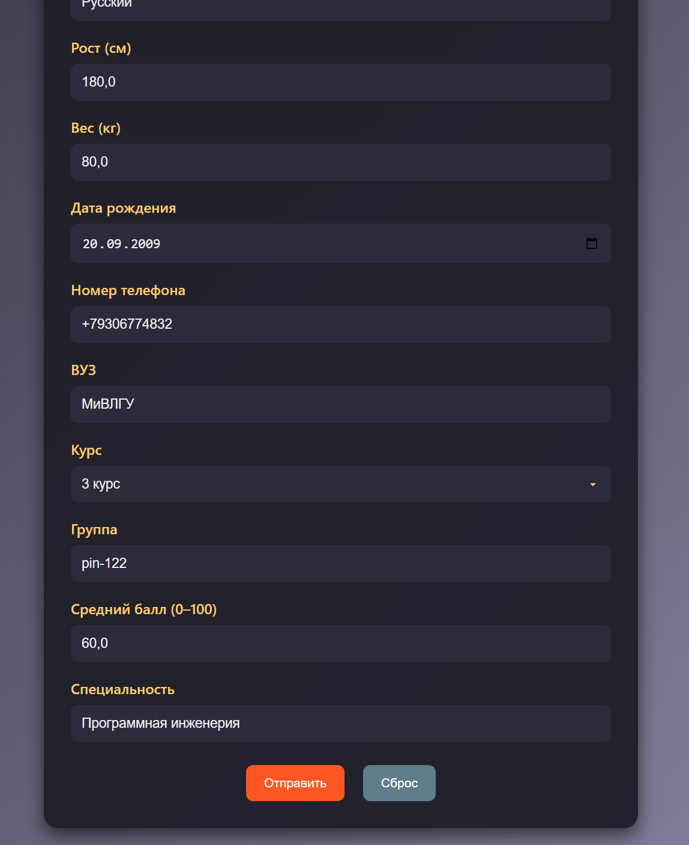
Рисунок 4 – Редактирование студента

В результате получаем корректное редактирование студента:
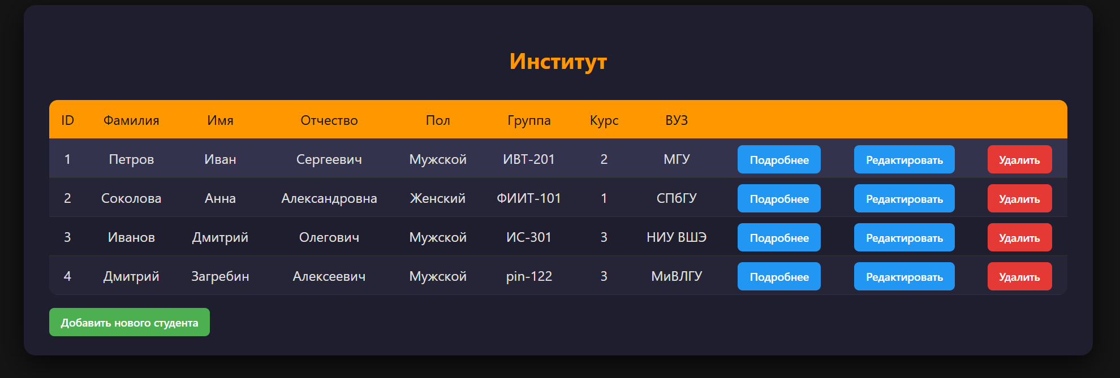
Рисунок 5 – Успешное выполнение редактирования

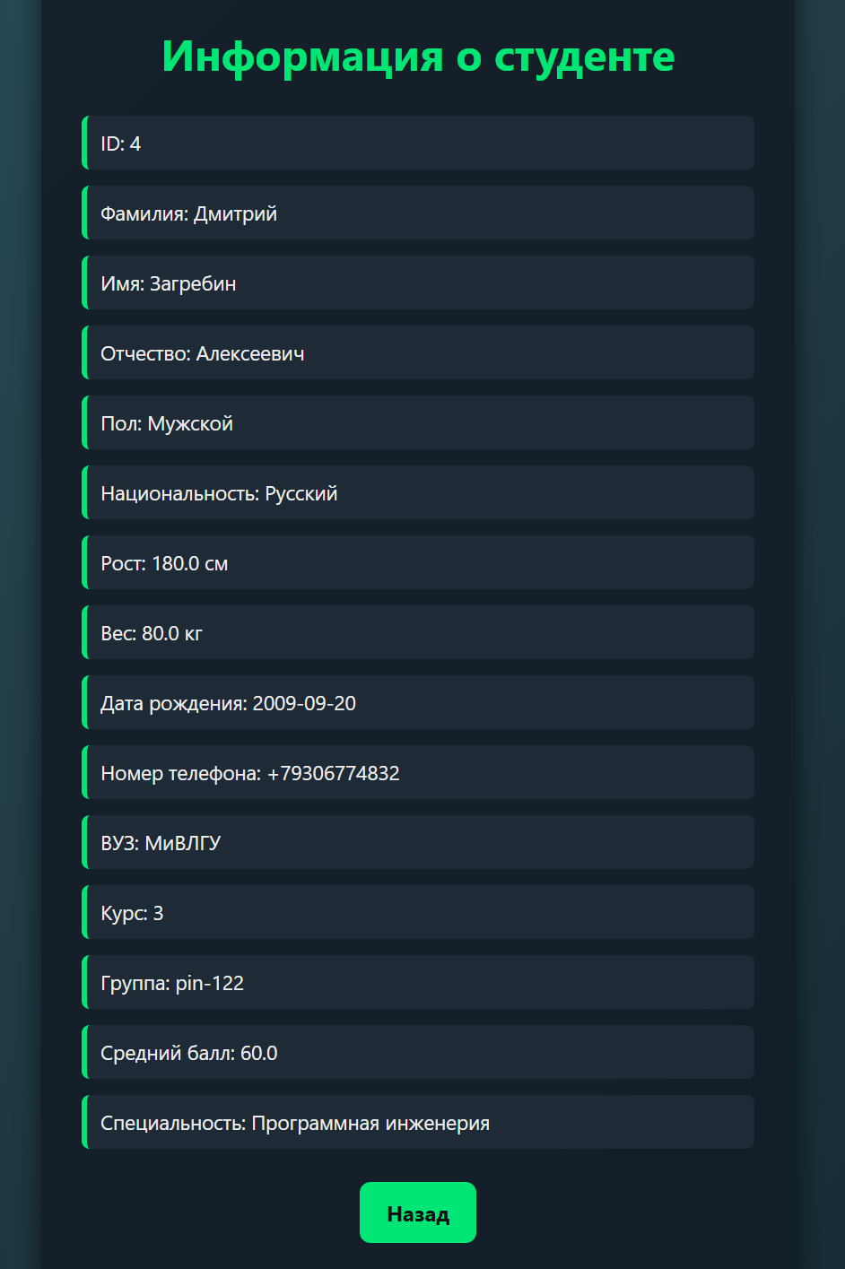
Рисунок 6 – Просмотр подробной информации о студенте

Демонстрация удаления. Для проверки функции удалим первого студента (ID=1):

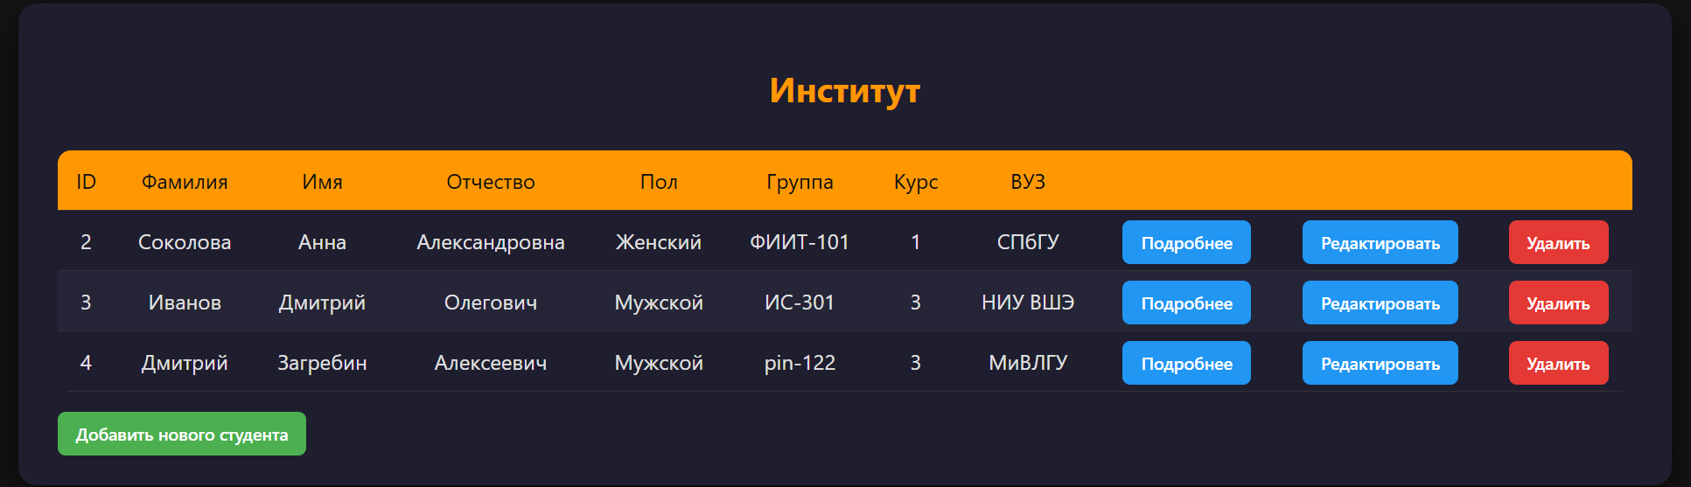
Рисунок 7 – Успешное выполнение операции

Вывод: Входе лабораторной работы был изучен способ использования репозитория в Spring Data JPA

